Testing

Chrome

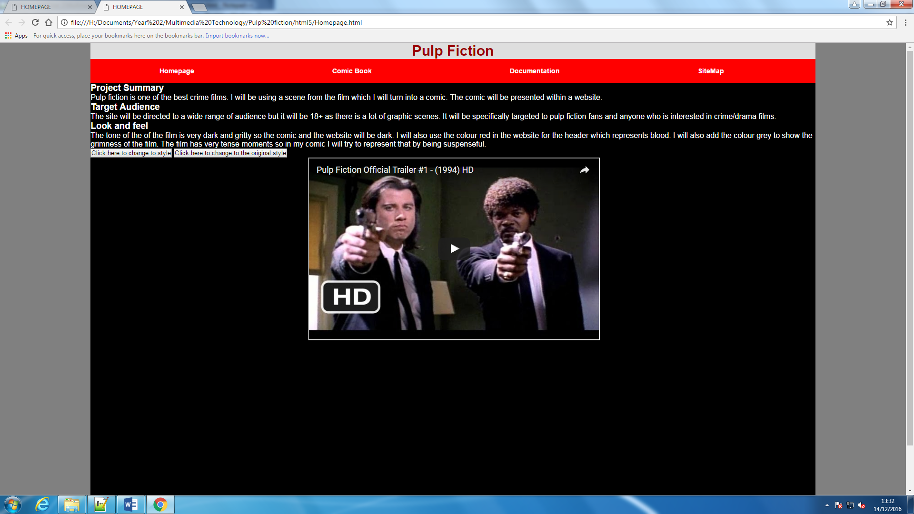

This is a print screen showing that my website works on google chrome.

Firefox

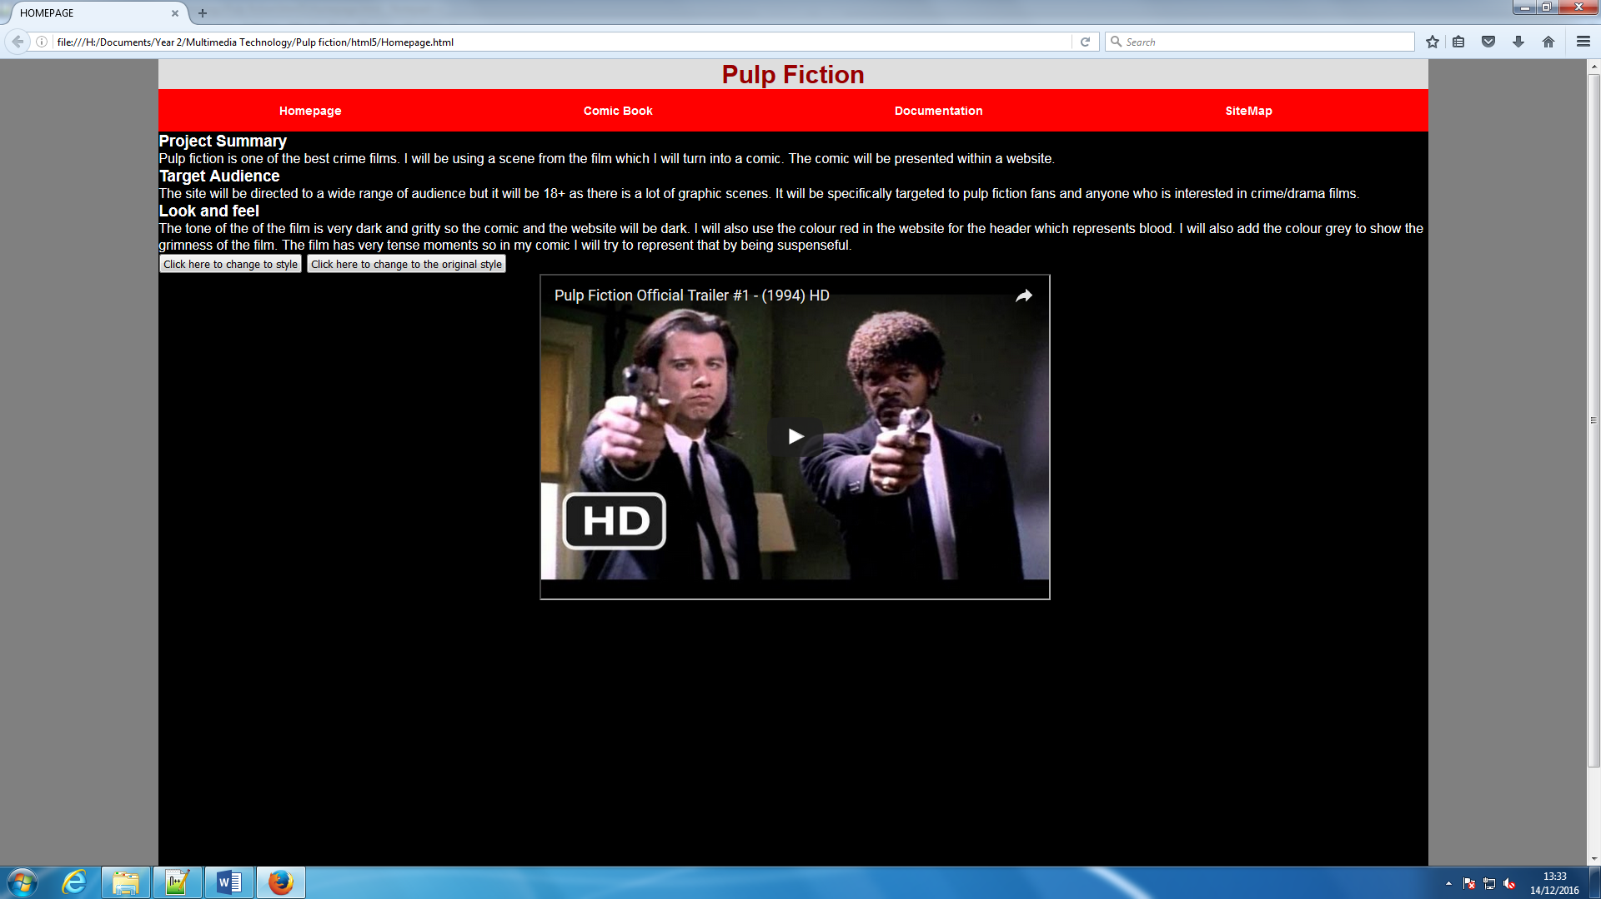

This is a print screen showing that my website works on Firefox.

Internet explorer

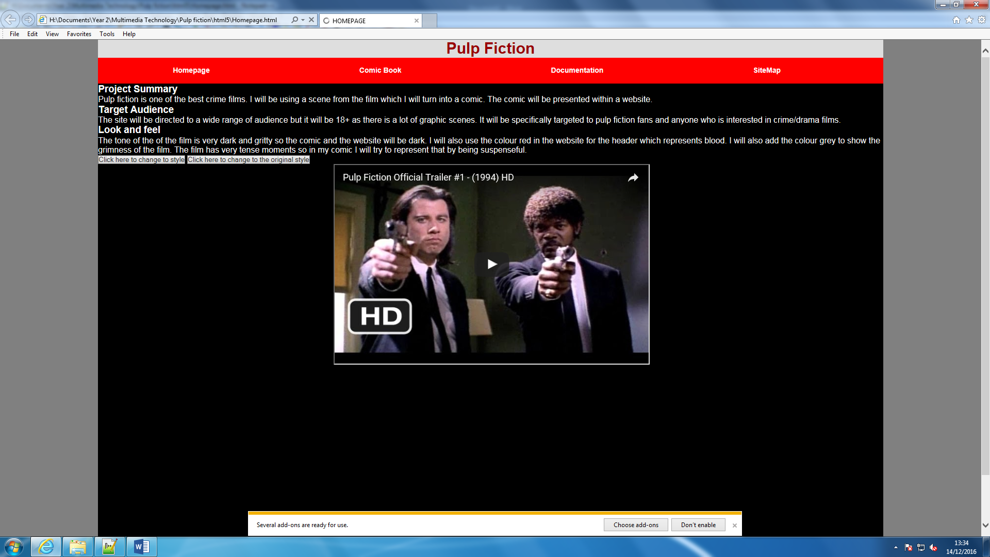

This is a print screen showing that my website works on internet explorer.

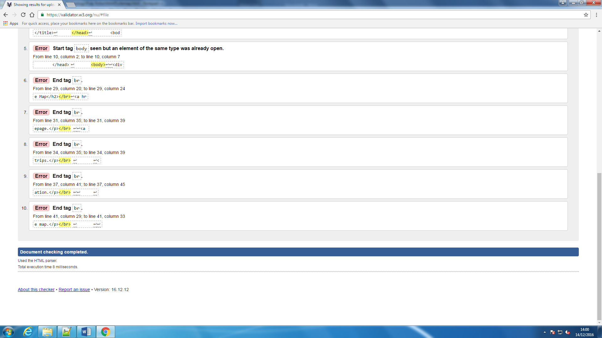

This is a print screen showing that I have error in my html with <br> tags.

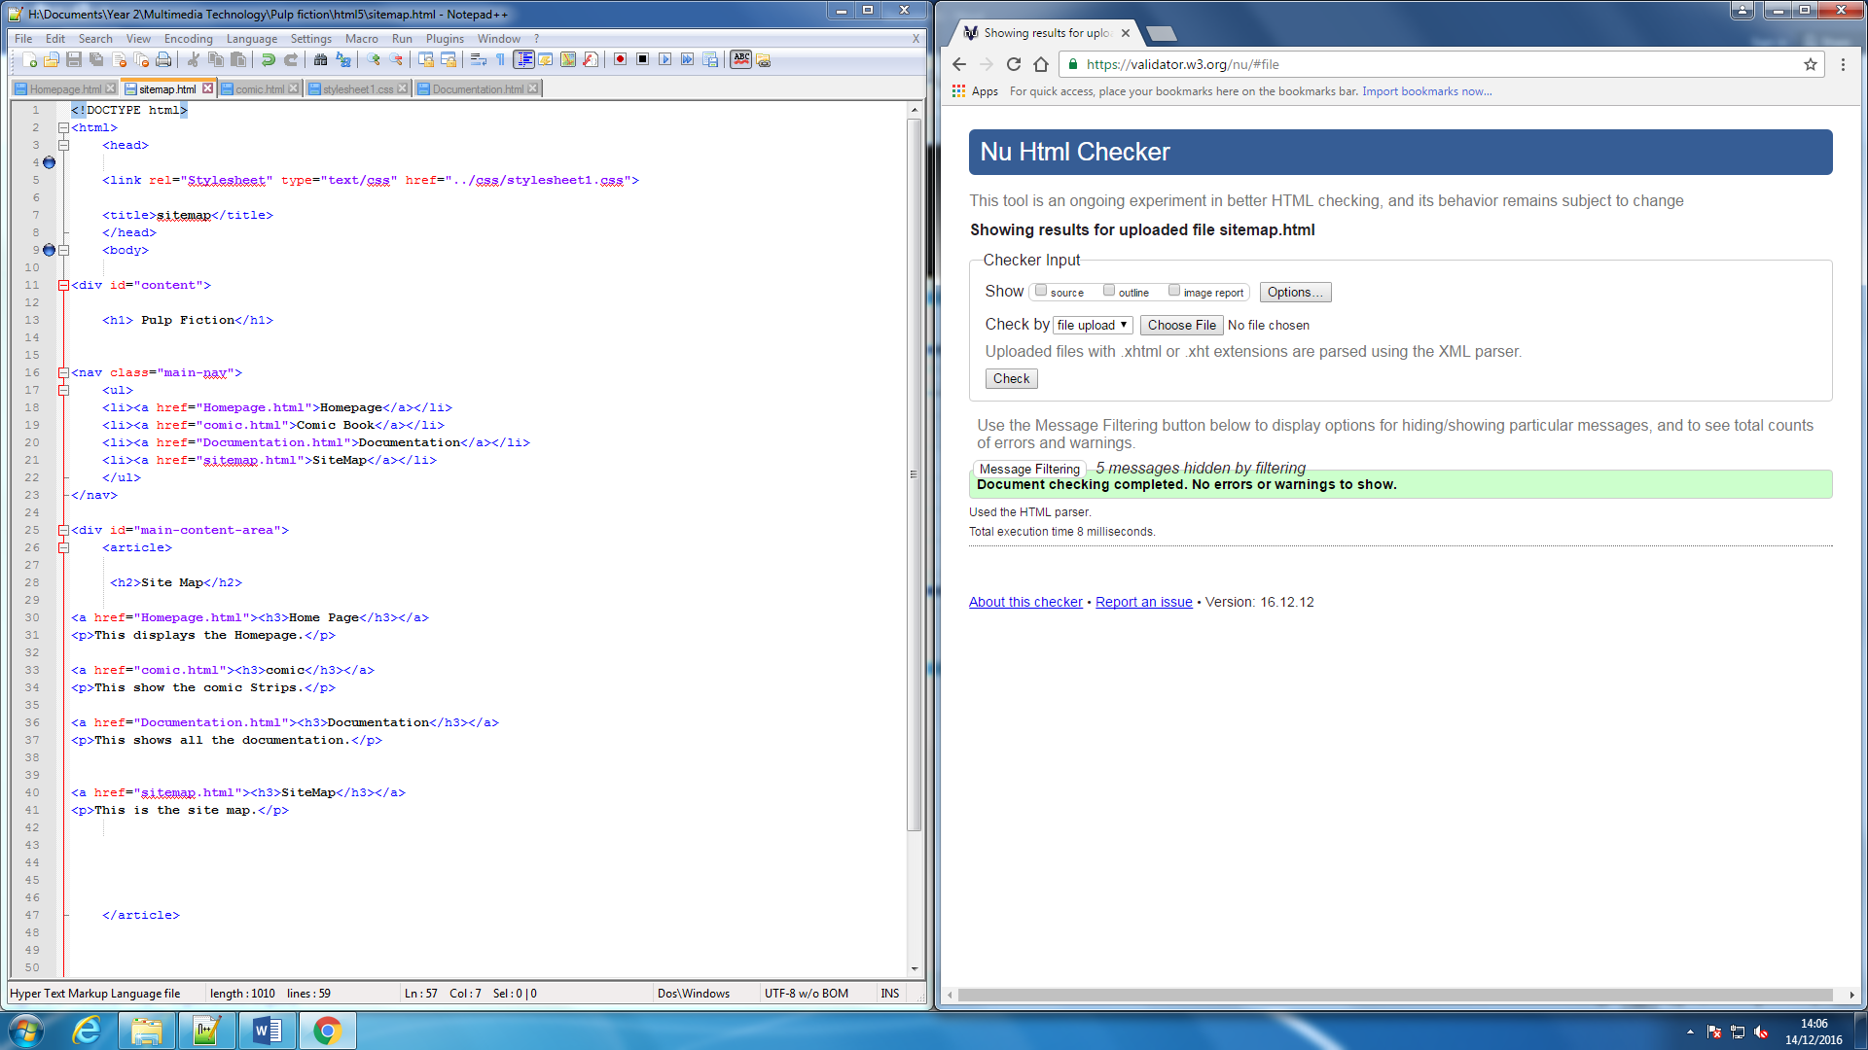

This is a print screen showing that I have removed the errors.

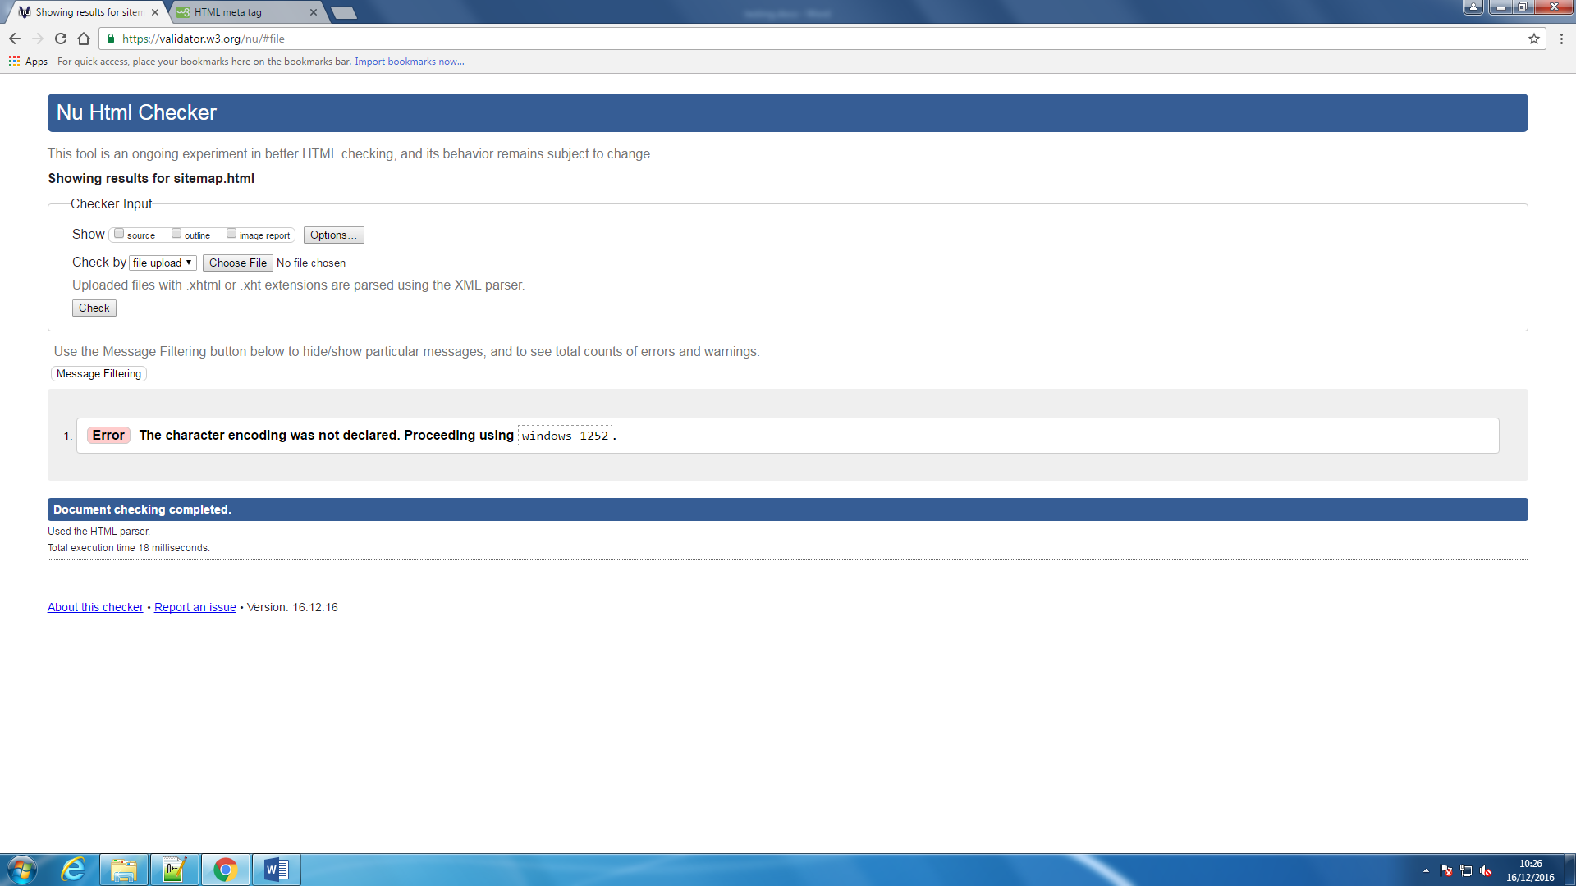

This print screen shows that I have an error in my sitemap.html.

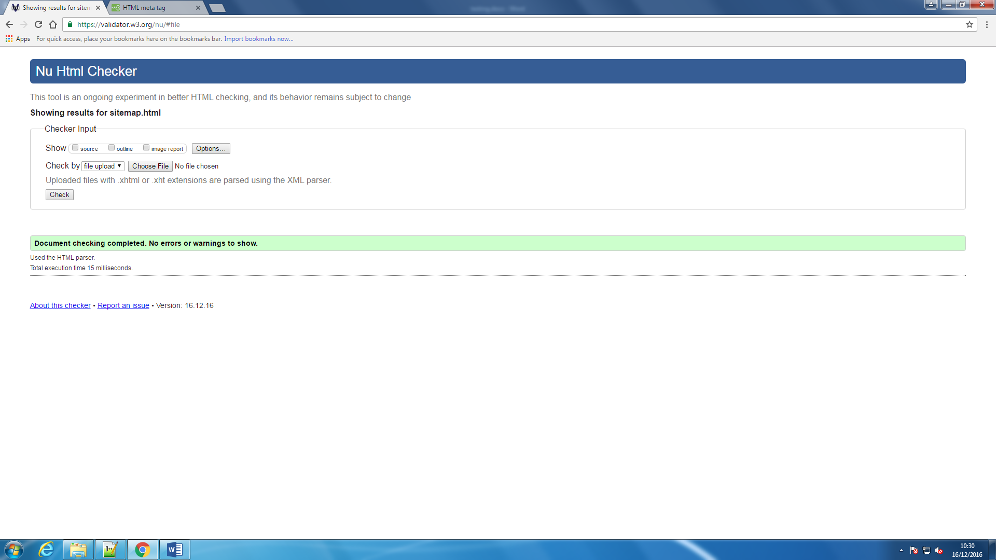 This is a print screen showing that I have solved the error.

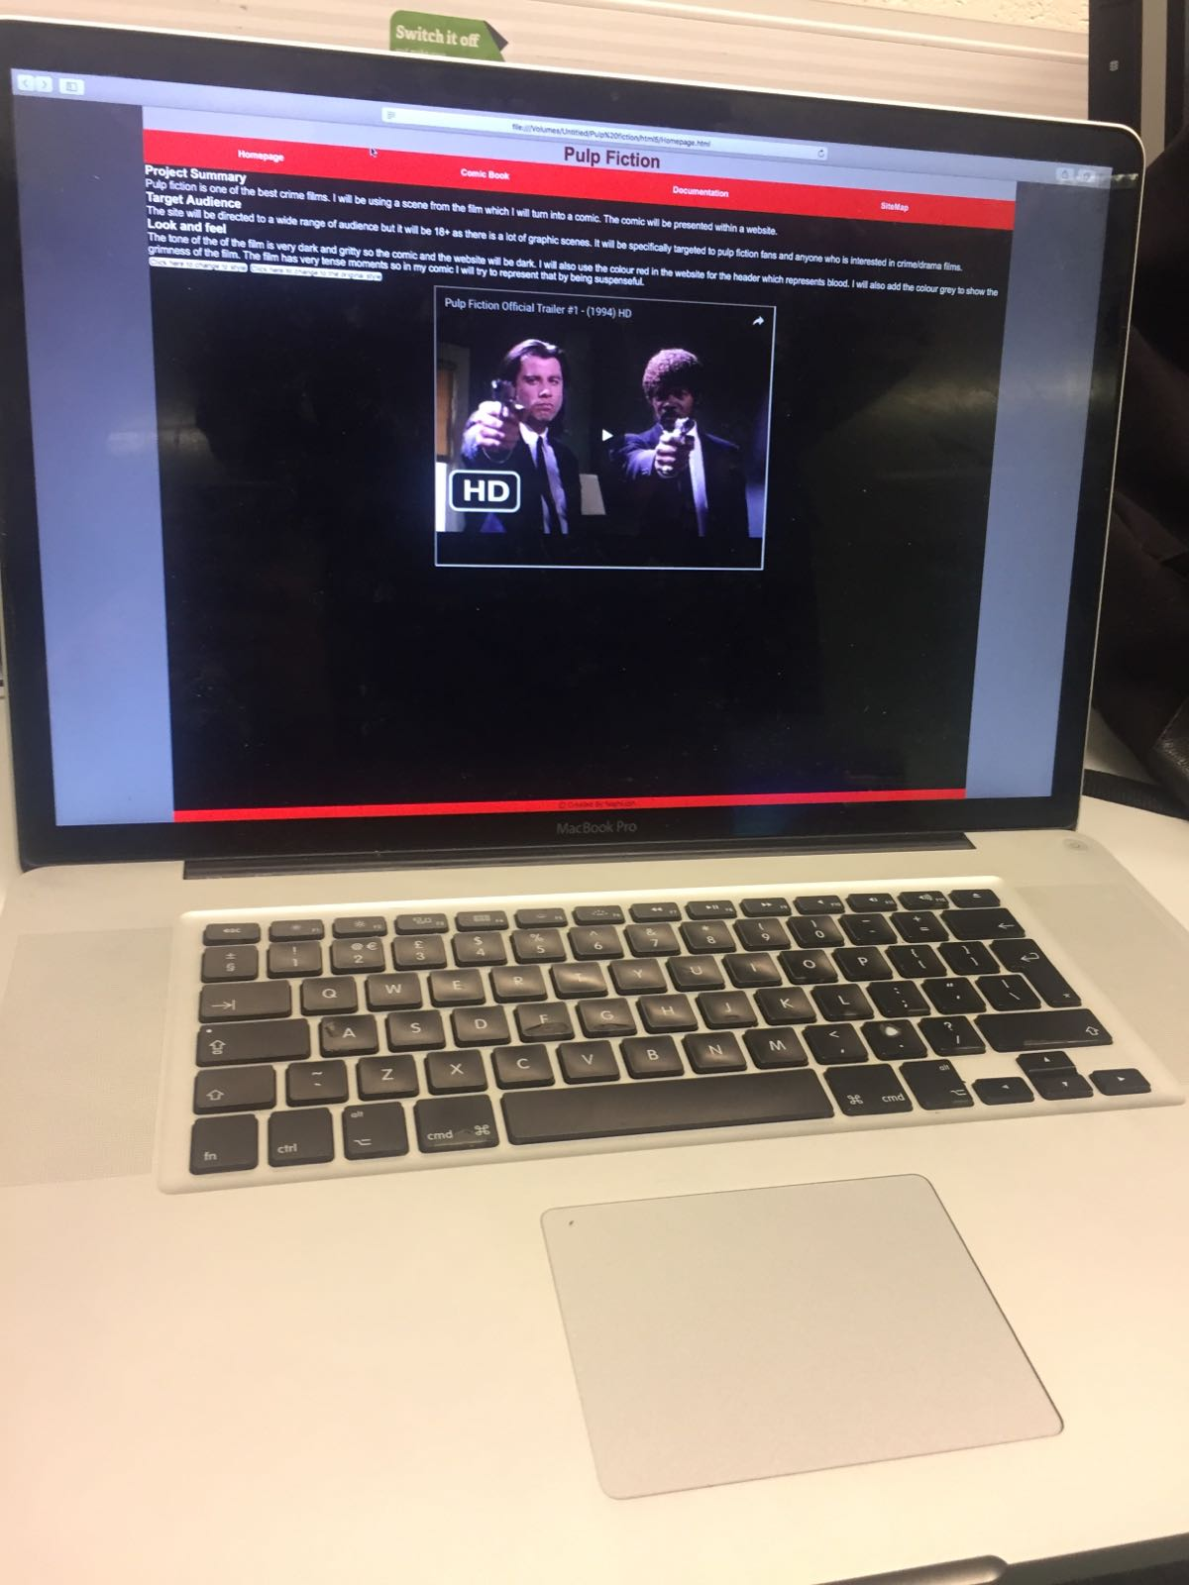

This is a print screen showing that I teseted the website on a different platform and in this case it is mac.

Resolution

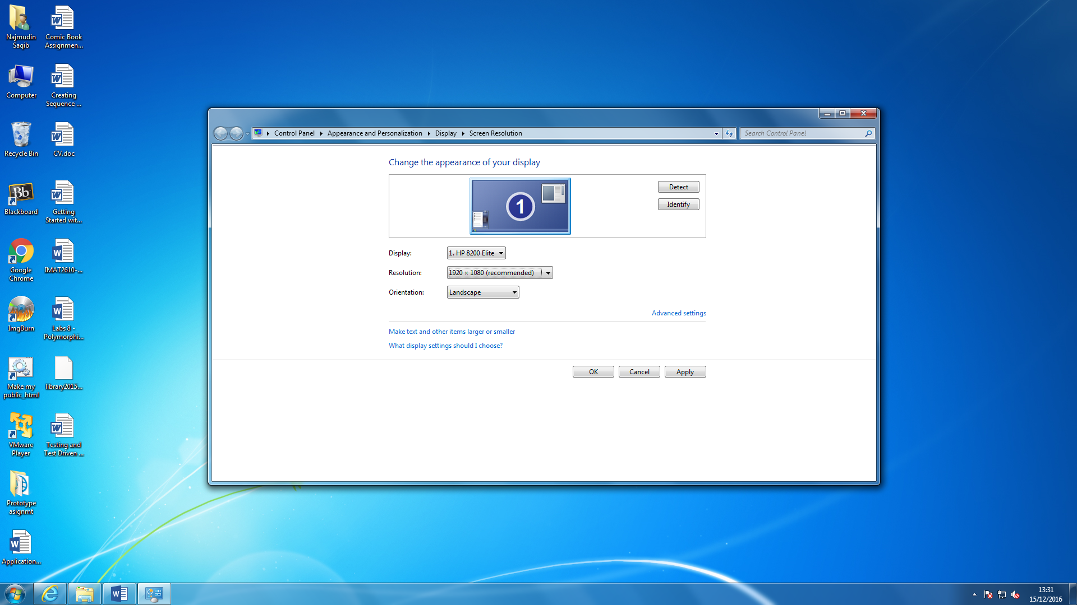

This is a print screen showing the resolution is at 1920 x 1080.

Result:

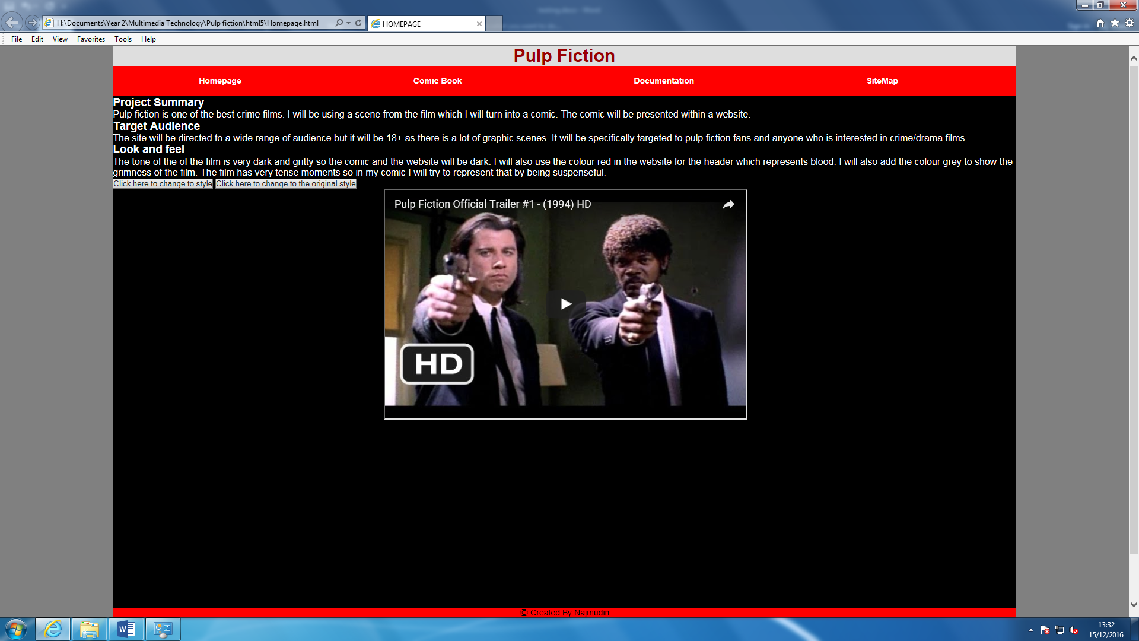

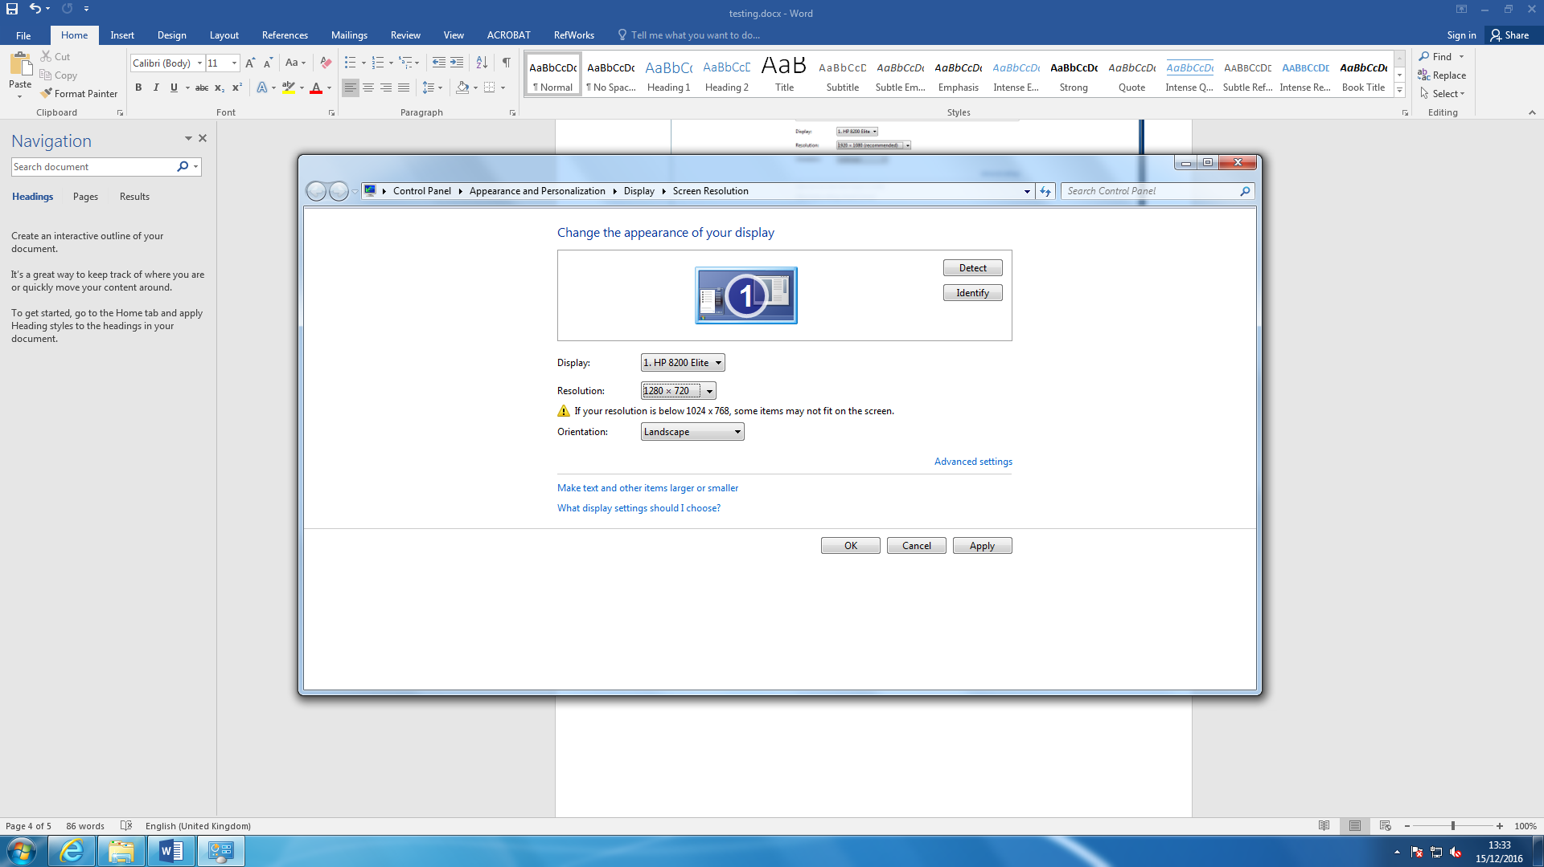

This is a print screen showing the resolution is at 1280 x 720.

Result:

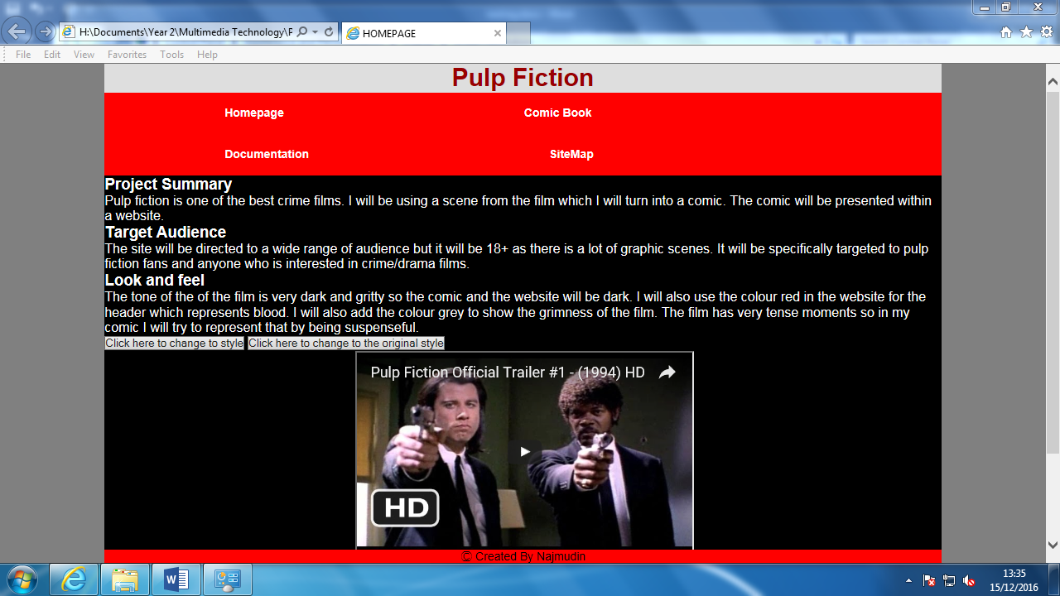

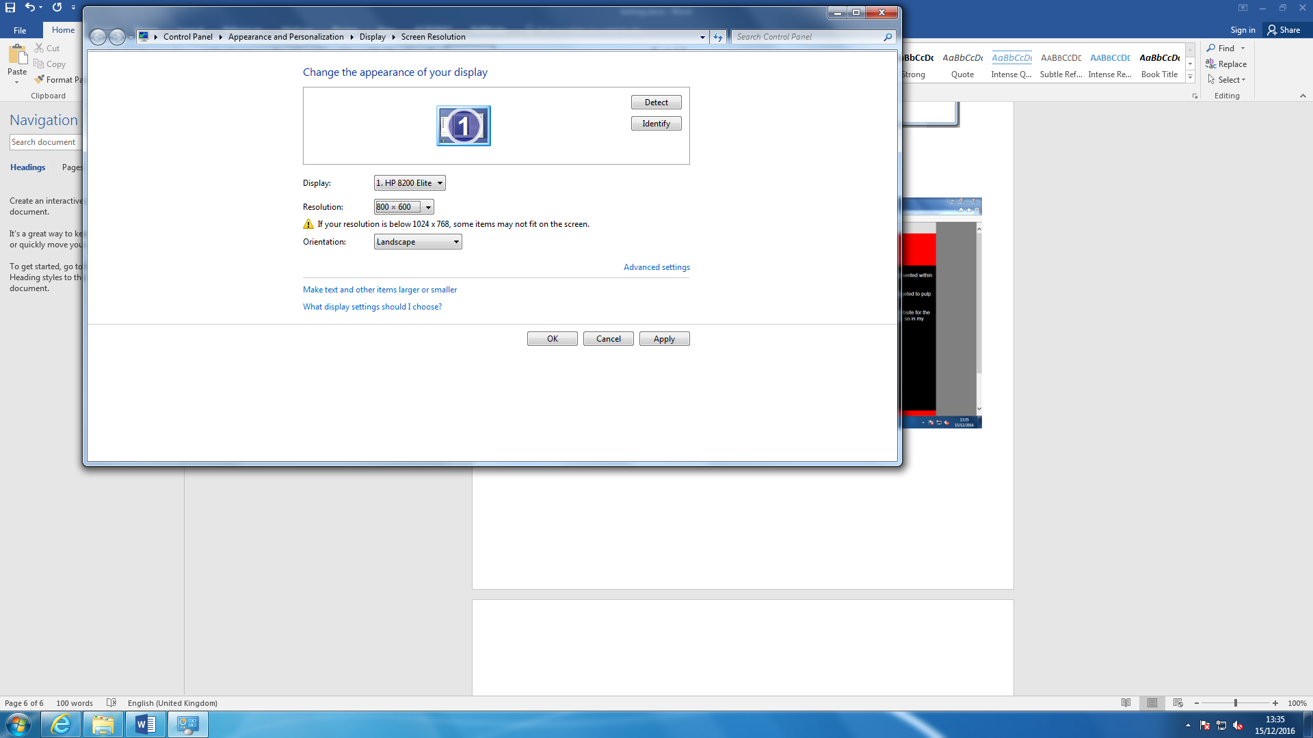

This is a print screen showing the resolution is at 800 x 600.

Result:

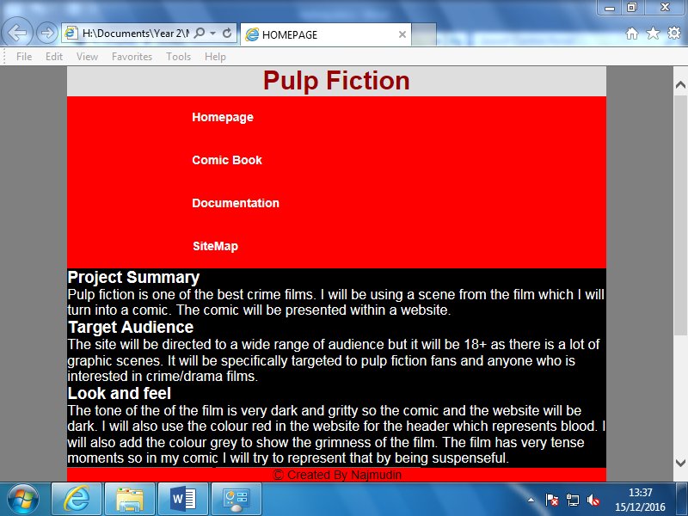

**Questionnaire**

1. Is the website Readable?

--------------------------------------------------------------------------------------------------

---------------------------------------------------------------------------------------------------

1. Is the site’s design aesthetically appealing?

--------------------------------------------------------------------------------------------------

---------------------------------------------------------------------------------------------------

1. Is the website easy to use? Rate from 1-5.

--------------------------------------------------------------------------------------------------

---------------------------------------------------------------------------------------------------

1. If you could change one thing about website, what would it be and why?

--------------------------------------------------------------------------------------------------

---------------------------------------------------------------------------------------------------

1. What do you like best about website?

--------------------------------------------------------------------------------------------------

---------------------------------------------------------------------------------------------------

1. How would you improve the website?

--------------------------------------------------------------------------------------------------

---------------------------------------------------------------------------------------------------

Questionnaire Results.